MAPPING SKILLS

If we want to know the location of place or to reach a specified point we should have the knowledge of the location. For the purpose the maps are useful to us. We can know the locations of various places. Latitudes and longitudes can be exploited for the purpose and learnt in under classes. Let us learn more about mapping skills. We can know more about Geographical locations.

**MAPPING SKILLS:-**

1. Scale

2. Directions

3. Compass

4. Height from the Sea level

5. Conventional Signs

**Map:-**

When the spherical earth is drawn to scale on a paper on any plain surface, it is called a map. The surface of the earth and its various geographical features can be shown fully or partly in maps. That means either the whole world or a country or a state or a small region can be shown on a map.

Types of Maps:-

* Political maps
* Physical maps
* Weather conditions,
* Forests,
* Asoka Empire
* Distribution of population
* Special maps

Sketch map:- Students are interested to draw the maps of imaginated aspects with the help of sketch map (If a draw a map) without using scale and direction of a place is called sketch maps

Scale:-

To show various geographical features of a region as they are on a map, we need a plain paper of the same size equal to the dimensions of that particular region. As it is a difficult task, maps are drawn by reducing the actual distances. For example, a distance of one kilometer between two places can be reduced and shown as one centimeter on a map. This reduction or ratio is known as the scale of that map. With the help of this scale, the actual distance between various features can be known by measuring the distance on the map between the same places.

The scale of a map is shown either in a statement from or a line scale or both ways. For example, see the map given here under.

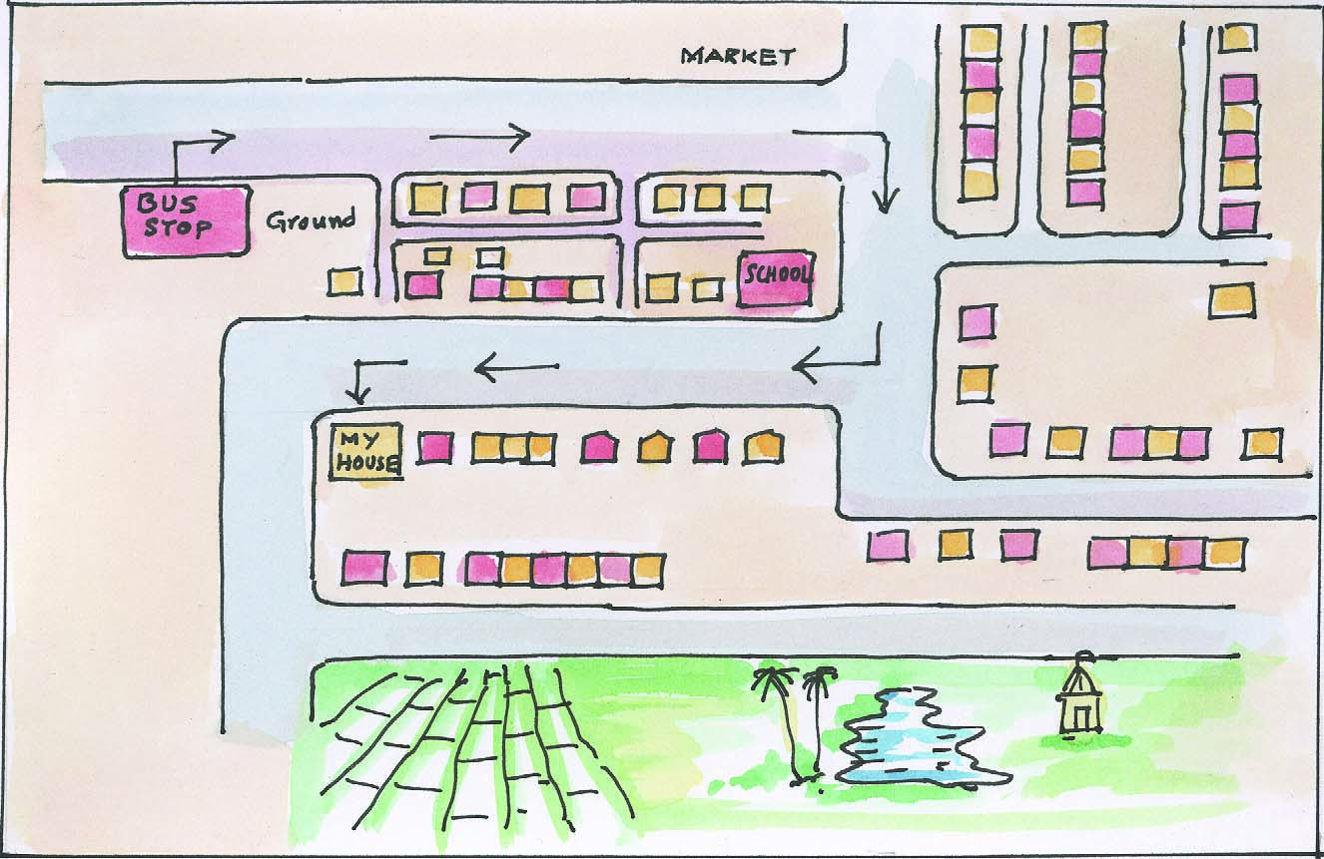

Sketch map

Fig.



**Map** (scale and directions)

Cardinal Points;-

Some features of a town are shown in the map. An arrow mark is shown on the top right hand corner and a letter ‘N’ is shown at the top of that arrow mark. That is, the edge of the arrow mark indicates the northern direction. The direction directly opposite to the North is called the ‘South’. Right side of the North South line is the East, and the left side is the West. All other directions can be easily identified if the North direction is known to us. These four directions of a compass are known as cardinal points.

In the same way if we know the four cardinal points, it is easy to know other four directions also which are in between them. For example, the direction between north and east is North-East. That between south and east is South-East. The one between south and west is South-West, and the direction between north and west is North-West.

See fig ..







* Ask the pupils to stand up in above pattern. Ask in which direction Shehanaz and

Ahmad and David and Anvesh are standing up.

Bearing:-

Bearing of an object is the clockwise angle measured from the north – south line to a line connecting the observer’s position with the object. In other words, it is an angle between the object and the observer and north – south line.

In figure, O is the position of the observer. The line OP connects the object P with O and makes a clockwise angle of 600  with the north-south line (NS) passing through the observer. Thus, the bearing of object P with reference to the observer O is 600 . Similarly the point Q makes a clockwise angle of 3300 with NS line passing through O. Hence, the bearing of Q with reference to the observer O is 330o.

**Magnetic Bearing**: A bearing with reference to magnetic north-south line is called Magnetic Bearing.

**True Bearing:** A bearing measured with reference to geographic north-south line is called True Bearing.

There are many ways for finding the direction of the North but a better preferred way is with the help of a magnetic compass. The needle of the magnetic compass always points towards the Magnetic North pole. The Magnetic North-south line is not the same as the True North-South line and the Magnetic North-South line is known as Magnetic Declination.









**Topographical Maps:**

**The survey of India has made Topographical maps or topo sheets** for India and the adjoining countries on different scales. These maps are based on the actual survey of land and their scale is large enough to show the relief through contours, drainage patterns, land use, settlement patterns, means of transport and many other details.

The study and understanding of the topographical maps or topo sheets require a comprehensive knowledge of physical geography as well as the human responses to natural environment. This type of study is essential for a student of geography for understanding the systematic and the regional geography of an area.

Initially the topo sheets were prepared by the Survey of India for the Indian Subcontinent and the adjoin areas of Iran, Afghanistan, Myanmar and China. The scales used were 1’’:4 miles and 1”:1 mile after the introduction of the metric system of measurement in India, the scales of these topo sheets were changed to 1; 1,000,000, 1:250,000 AND 1:50,000.(Ex: 1cm=10km)



Million sheets

India and the adjoining countries are divided in 4”x 4” sheets. The extent of each sheet is 4 of latitude and 4 of longitude. These are numbered as 45, 46, 47, and so on. The scale of the sheets in this series is 1: 1, 000, 000.

Quarter Sheet or Quarter Inch Map:

Each 4o x 4o sheet is sub-divided into j16 equal parts. The extent of each part or sheet is 1o of latitude and 1o of longitude. These are numbered from A to P and written as 55A, 55B, right up to 55P. The scale of the sheets in this series is 1:250,000.

Quadrant Sheet or Inch Map:

Each 1o x 1o sheet is sub-divided into 16 equal parts. The extent of each part or sheet is 15 of latitude and 15’ of longitude. These are numbered from 1 to 16 and written as 55 J/10. The scale of the sheets in this series is 1:50,000. Each sheet covers an area of about 1800 sq.km.



*Draw the Sketch map of your school.

*Draw again the sketch map of your school with the help of scale and directions.

point: - Print always indicates the relation between a centre point or centre place to other aspects.

For example Vizag is East side to Hyd. For any place on earth surface has 4 directions or points. These are called cardinal points. East, West, North, South inconvenience.

If we want to know the (location of a place or to reach that place, we must have necessary knowledge about that place. Mapping skills are to know the way to reach a place or to say about the place where we stand.

With the help of maps we can locate or identify the different places. We have already learnt the usage of latitudes and Longitudes in last class. Let us know about the mapping skills. We can understand the Geographical aspects through map.

For example Vizag is East side to Hyd. For any place on earth surface has 4 directions or points. These are called cardinal points. East, West, North, South inconvenience.

If we want to know the (location of a place or to reach that place, we must have necessary knowledge about that place. Mapping skills are to know the way to reach a place or to say about the place where we stand.

With the help of maps we can locate or identify the different places. We have already learnt the usage of latitudes and Longitudes in last class. Let us know about the mapping skills. We can understand the Geographical aspects through map.

1. Map: - When the spherical earth is drawn to a scale on a paper or on any plain surface. It is called a map
2. Like this sampth sat in the Class room in the west direction to revi Teja shaker sat in south direction to sampth internationally north directions has a great importance

Next impoance given into south, east, west. The above points help to locate North direction of a place which leads easy location of other direction.

When we know the four directions. We can easily understand the other internal direction. The direction between North and East known as _____>

And the direction between South and East is known as _______>, the direction between North and West is known as______> and the direction between North and West is known as _____>

Activities:-

1. Stand a student in the center of the class room and ask them to locate the four main directions.
2. Ask the students to explain the aspects of and directions in the class room.
3. Ask the student stand in shape and to locate their of direction.

Types of Maps

Different types map can be used to make social studies interested

1. Relief Maps: - They may be considered as a model of the Geo graphical features of a place. They should be used where geo graphical features have a direct influence onthe course of events. Forexample, relief map of the north-Westerns frontiers can be very useful show why so many invasions took place through the places.
2. Flat Maps:-

Flat maps of different kinds, for instance, political, physical, population, roads and the like, can be very useful. Flat maps may also be used for showing campaigns, treaties, boundaries, routes of armies, routes of travels, etc.

1. Sketch maps: - These are maps in outline. They can be used according to necessity. These maps are very useful whenever we are to deal with the course of action followed by an invader, e.g., samudragupta’s Deccan campaign, Alexander’s invasions etc.

MEANING OF THE COLOURS (TINTS) ON A TOPO SHEET

Many colours are used on a topo sheet to represent certain physical, economic or cultural features. /the details are as under:

1. The blue colour is used to show all physical features associated with water such as Seas Rivers, ponds, wells, etc.
2. The black colour is used for showing all names, dry water bodies, (such as dry streams, wells, ponds, river banks), boundaries, railways, telephone and telegraph lines, grid of the parallels and meridians, surveyed tress, heights, etc.
3. The green colour is used for showing forested areas, trees, scrubs, orchards, etc.
4. The cultivated areas are highlighted in yellow.
5. The area with white colour shows the uncultivated land.
6. The brown colour is used for showing contours, their numbers, formlines, sand dunes, etc.
7. The red colour is used for settlements, roads, and arbitrary gridlines that are eastings and northings.
8. Contours: The method of showing relief through contours is perhaps the most accurate, common and popular. A contour is an imaginary line drawn on map joining the points having the same elevation above mean sea level. Contours are also known as ‘isohypes’ where ‘iso’ means equal and ‘hypes’ means heights.

The fig. below represents an island with two hills linked by a lower ridge. The dotted lines in this diagram represent the levels on the hillsides at which heights of j100 metre, 200 metre, 300 metre and 400 metre respectively are attained. They therefore, represent contour-lines. If the island were to sink or the sea to rise 100 meters, the 100 metre contour level would become the new coast-line and would represent sea-level. In the diagram a contour map of the area has been drawn.

1. Form lines: These are broken lines between contour lines to indicate minor details.
2. Spot heights: These are marked on the map by a dot and an associated number e.g.341.
3. Bench marks: These are marks on buildings or other permanent structures. These marks are shown by letters BM along with height e.g.BM 580.
4. Trigonometrical stations: These points show height and are marked by a triangle and height e.g.∆ 866.

Cartography: Cartography is an art and science of drawing maps, diagrams and charts.

ARBITRARY GRID SYSTEM

The arbitrary grid system is helpful jin locating places on the. The main features of the arbitrary grid system drawn on the topo sheets on the scale of 1:50,000 are as under.

* The southwest corner (bottom left) of the topo sheet is always taken as the starting point or the point of reference for the grid system.
* The grid lines running vertically (from north to south) are called the Eastings, as these lines lie towards the east of jthe wouthwest corner.
* The grid lines runnin g horizontally (from east to west) are called the Northings, as these lines lie towards the north ofj the southwest corner.
* The eastings and the northings intersect to form a netweok of sqares called the grid system.
* Each square in the grid system is called a grid square.
* The point of intersection between the eastings and northings on the topo sheet is called the co-ordinates.
* The grid lines (the eastings and the northings) on the topo sheet drawn on the scalej of 1:50,000 are always 2 cm apart, representing a distance of 1 km on the ground.
* The grid square on the topo sheet represents an area of 1km on the ground.
* The grid lines (the eastings and the northings) are always numbered in two digits, such as 00,01,02….97,98,99.
* The value of the eastings increases, numerically, eastwards from the southwest corner.
* The value ofj jthe northings increase, numerically, northwards from the wouthwest corner.
* There are two types of grid references-the four –figure grid reference and the six-figure grid reference.
* While finding the location of a place on a topo sheet , mention the easting jon the left ofj the place and the northing below the place.
* While giving the grid reference of a place, the eastings are always quoted first, and then the northings.

EXTRA INFORMATION

1. Map: - When the spherical earth is drawn to a scale on a paper or on any plain surface. It is called a map
2. Like this sampth sat in the Class room in the west direction to revi Teja shaker sat in south direction to sampth internationally north directions has a great importance

Next impoance given into south, east, west. The above points help to locate North direction of a place which leads easy location of other direction.

When we know the four directions. We can easily understand the other internal direction. The direction between North and East known as _____>

And the direction between South and East is known as _______>, the direction between North and West is known as______> and the direction between North and West is known as _____>

Activities:-

1. Stand a student in the center of the class room and ask them to locate the four main directions.
2. Ask the students to explain the aspects of and directions in the class room.
3. Ask the student stand in shape and to locate their of direction.

Types of Maps

Different types map can be used to make social studies interested

1. Relief Maps: - They may be considered as a model of the Geo graphical features of a place. They should be used where geo graphical features have a direct influence onthe course of events. Forexample, relief map of the north-Westerns frontiers can be very useful show why so many invasions took place through the places.
2. Flat Maps:-

Flat maps of different kinds, for instance, political, physical, population, roads and the like, can be very useful. Flat maps may also be used for showing campaigns, treaties, boundaries, routes of armies, routes of travels, etc.

1. Sketch maps: - These are maps in outline. They can be used according to necessity. These maps are very useful whenever we are to deal with the course of action followed by an invader, e.g., samudragupta’s Deccan campaign, Alexander’s invasions etc.
2. MAPPING SKILLS

|  |  |  |
| --- | --- | --- |
| 45 | 54 | 63 |
| 46 | 55 | 64 |
| 47 | 56 | 65 |

1. MILLION SHEETS

|  |  |  |  |
| --- | --- | --- | --- |
| **A** | **E** | **I** | **M** |
| **B** | **F** | **J** | **N** |
| **C** | **G** | **K** | **O** |
| **D** | **H** | **L** | **P** |

1. QUARTER SHEETS

|  |  |  |  |
| --- | --- | --- | --- |
| **1** | **5** | **9** | **13** |
| **2** | **6** | **10** | **14** |
| **3** | **7** | **11** | **15** |
| **4** | **8** | **12** | **16** |

1. **QUADRANT SHEETS**

